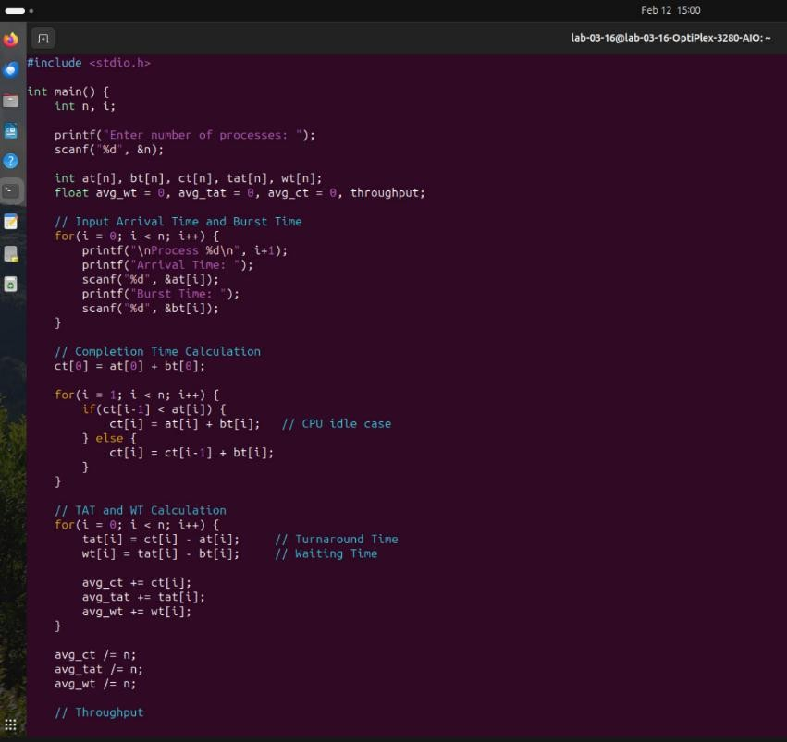

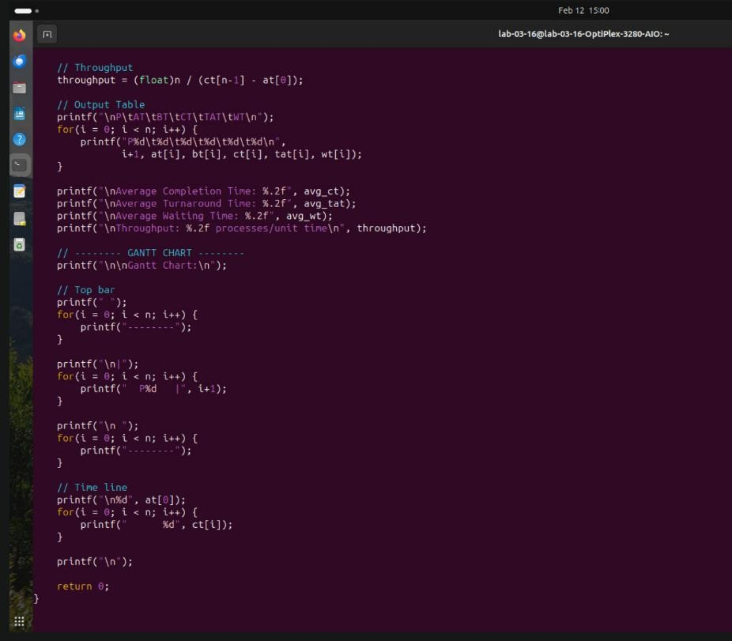




Arr:val line: ž i î me: 3

A ical Tone: S

Are age tonplel' ice: 9.00 A era e Ÿroaroood ice: 5.00 Average úa:îiJg Time: 2.00

